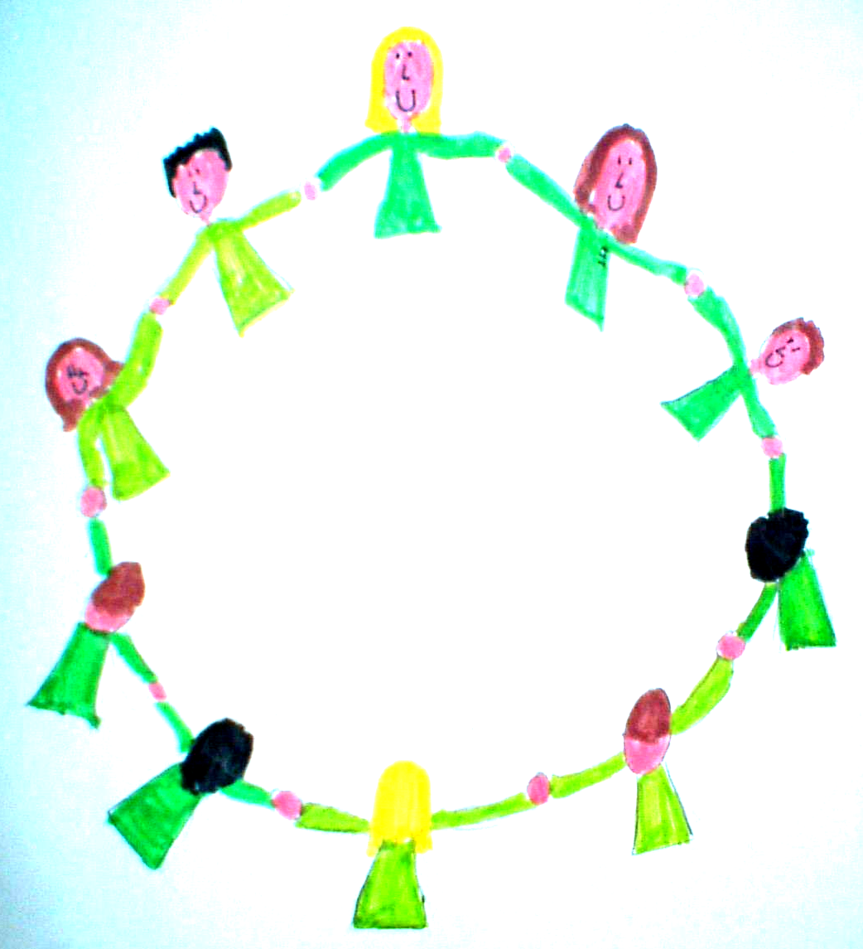
Stroud Valley Community Primary School –
Relationships and Sex Education (RSE)

As a maintained school we must provide Relationships Education to all our pupils under sections 34 of the Children and Social Work Act 2017. We are not required to provide Sex Education, but we do need to teach the elements of Sex Education contained in the science curriculum.

Following this guidance, we believe that all pupils should benefit from high quality Relationships and Sex Education (RSE), providing them with a safe and supportive environment in which to develop the knowledge they need to make wise and informed choices later in life.

We believe all children have an entitlement to RSE education and carefully consider their needs in terms of their understanding, sexual orientation and cultural background. We value different backgrounds and beliefs and aim to promote tolerance and understanding.

Learning about sex and relationships can provide the ideal forum to challenge stereotyping and views such as those around homophobia and gender sexual stereotyping.

Relationships and sex education is lifelong learning about the physical, moral, emotional, social and cultural development of children. We focus on positive relationships including:
- families and people who care for me
- caring friendships
- respectful relationships
- online relationships
- being safe
These areas of learning are taught within the context of family life, taking care to make sure that there is no stigmatisation of children based on their home circumstances. We consider that some children may have a different structure of support around them and are sensitive towards these.

It involves learning about relationships, sexual health, sexuality, healthy lifestyles, diversity and personal identity. RSE involves a combination of sharing information, and exploring issues and values. It is not about the promotion of sexual activity.

It is about understanding the importance of loving and caring relationships. We learn about relationships, healthy life styles, diversity, personal identity, sexual health and sexuality. RSE is about teaching children to develop comfortable personal boundaries and knowledge of the adults they can talk to if they feel those boundaries have been breached.

We aim to:
- provide a framework in which sensitive discussions can take place
- answer questions factually and encourage discussion as appropriate;
- help children develop feelings of self-respect, and respect for others
- encourage children to have respect for all relationships
- develop skills (language, decision making, assertiveness, and empathy) to make the most of their lives
- teach children the correct vocabulary to describe themselves and their bodies
- provide children with the factual information and knowledge that will enable them to make informed choices about their lives
- create a positive culture around issues of sexuality and relationships
- encourage responsibility for themselves.
- prepare children for puberty
- give them an understanding of sexual development and the importance of health and hygiene
- develop the notion of consensual relationships

How we teach RSE

Relationship and sex education is taught through our PSHE curriculum and we follow a series of lessons from the scheme Kapow. The scheme aims to give children the knowledge, skills, and attitudes that they need to effectively navigate the complexities of life in the 21st Century.

All children are treated equally and RSE is taught in mixed sex groups unless we feel specific objectives are better met in single sex groups. It is important that all children learn about their own bodies and those different from their own to enable them to develop healthy relationships with themselves and with others.

If pupils ask questions outside the scope of this policy, teachers will respond in an appropriate manner so that pupils are fully informed and don’t seek answers online.

RSE is taught in a safe, non-judgmental environment where adults and children feel confident they will be respected.

Children will be taught and supported with developing the following skills:
- communication, including how to manage changing relationships and emotions
- to maintain and develop a sense of safe, personal boundaries
- recognising and assessing potential risks
- assertiveness
- seeking help and support when required
- informed decision making
- self-respect and empathy for other
- recognising and maximising a healthy lifestyle
- managing conflict

Parental Consent
Parents have the right to withdraw their children from the non-statutory components of RSE.
These are the additional learning points that are not part of the science curriculum.

Prior to teaching the non-statutory elements of RSE, we will provide in writing, an overview of the learning objectives as well as key vocabulary which will be used. If a parent feels they would like to understand more about the content of the non-statutory elements of RSE whilst deciding whether to withdraw their children from RSE please contact the school to arrange a meeting.

If a parent feels this request is appropriate we ask they discuss their decision with the class teacher. If after further explanation about the content of the RSE curriculum we ask that the parent put their decision to withdraw in writing.

Safeguarding
One outcome of our RSE work is that children are enabled to protect themselves and ask for help if necessary. We want them to understand what constitutes a safe and unsafe situation including actions to take if they feel unsafe at any time.

RSE is taught in an open, non-threatening way and we encourage children to talk.

We recognise that discussing relationships and sex with children may infringe on their experiences outside of school and may be a time when children disclose information. All staff are fully aware of our safeguarding procedures and will follow these if appropriate. Children must feel enabled to talk about concerns of inappropriate sexual behaviour or anything they feel uncomfortable about.

It will be made clear to children that they are able to talk to an adult in school at a separate time if they need to.

Monitoring and Evaluation
RSE is one part of our PSHE curriculum and will be monitored by the PSHE middle leader.

Policy Review
Policy Title | Sex and Relationships
Date Policy Ratified by Governors | June 2024
Committee Responsible | TLA
Date for next review

