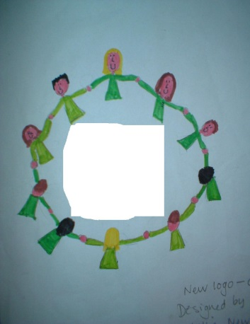

Stroud Valley Community School

SVCS

Governing Body

**REMIT OF THE GOVERNING BODY**

The Governing Body has the responsibility for ensuring the good conduct and high standards of educational provision and achievement throughout the school. Governors do this by setting the strategic direction of the school, ensuring the quality of the education is high and by holding the Headteacher to account. All governing boards have three core functions to support their school:

1. To ensure clarity of vision, ethos and strategic direction. We ask “Where is the school heading and what are the values of the school?”

2. To hold the Headteacher to account for the educational performance of the school and its pupils and the management of staff

3. To oversee the financial performance of the school and make sure money is well spent and supports the key direction of the school.

In Stroud Valley Community school the governing body is made up of local people who live in the community and want to achieve the best we can for the school and its families. As individuals governors have no power or responsibility. It is only the full governing body acting together which has legal duties and powers. All governors share that responsibility. We are proud to be governors and want to continue to support the excellent learning in Stroud Valley Community school by taking an active part in the local community and working in close partnership with the head and her team.

The Governing Body is made up of 13 members.

This consists of:

* 3 parent governors who are elected by the parents of the school.
* 1 Local Authority representatives
* 1 member of staff elected by the staff
* the Head Teacher
* 7 Co-Opted governors

These meet as a full group 4 – 6 times a year, equally spaced throughout the year..

There are also two focused committees groups:

* Finance, Staffing, Premises and General Purposes
* Teaching, Learning and Assessment

**Our Governors**

|  |  |  |  |
| --- | --- | --- | --- |
| **Name** | **Governor Category** | **Appointment Date**  **Term of Office** | **Further Information/Financial Pecuniary Interests** |
| Jackie Terry  (Chair) | Co-opted | 10/07/2023 | None |
| Christine Minett  (Vice Chair) | Co-opted | 21/03/2023 | None |
| Christine Barrett | Staff | 22/03/2023 | SENCO |
| Tim Davies | Parent | 08/04 / 2022 | None |
| James Harwood-Vandenbergh | Parent | 03/07/2023 | None |
| Sarah Heague | Co-opted | 22/03/2023 | DHT |
| Steve Hodgkinson | Co-opted | 20/10/2022 | Headteacher at another school |
| Clare Murphy | Co-opted | 12/02/2023 | None |
|  |  |  |  |
| Simon Pizzey | Co-opted | 22/03/2023 | None |
| Debbie Sleep | Headteacher |  | Headteacher |
| John Walton | Co-opted | 4/12/2020 | None |
| Rachael Scott | LA | 11/12/23 | None |
| Julie Howe | Associate | 13/7/21-12/7/25 Associate | Finance Committee |
| Vacancy | Clerk to Governing Body |  |  |
| Governors left within last academic year | | | |
| Darren Peters | Co-opted | 27/03/2023  Resigned 5/12/23 | None |
|  |  |  |  |

The staff governor is elected by the staff of the school.

The local authority governor is appointed by the LA.

Co-opted governors are appointed by the existing governing body/

The parent governor is elected by the parents of the school.

**Committees Governors (Attendance for year Sept 22 – July 23)**

|  |  |  |  |
| --- | --- | --- | --- |
| **Finance, Premises**  **Staffing and General Purposes** | | **Self Evaluation** | |
| Name | Attendance | Name | Attendance |
| C.Minett  (Chair) | 4/4 | J.Terry | 3/5 |
| Tim Davies | 4/4 | Simon Pizzy | 3/5 |
| John Walton | 3/4 | Chris Barrett | 4/5 |
| Julie Howe (associate) | 3/4 | Sarah Heague | 5/5 |
| James Vandenburg-Harwood | 1/2 | Chris Minett | 5/5 |
|  |  | Claire Murphy | 3/5 |

|  |  |
| --- | --- |
| Full Governing Body meetings Sept 23 – July 24 | Attendance |
| J Terry (Chair) | 4/5 |
| C Minett (Vice Chair) | 3/5 |
| Christine Barrett | 3/5 |
| Tim Davies | 3/5 |
| James Harwood-Vandenbergh | 3/5 |
| Sarah Heague | 4/5 |
| Steve Hodgkinson | 5/5 |
| Clare Murphy | 4/5 |
| Simon Pizzey | 3/5 |
| Debbie Sleep | 5/5 |
| John Walton | 3/5 |
| Rachael Scott | 3/4 |